Fast**1111111111111111111111111111111111111111111111111111111111111111**

**FAST- National University of Computer & Emerging Sciences, Karachi.  
Department of Computer Science  
Quiz- I, Fall 2019**

**20th September 2019**

|  |  |
| --- | --- |
| **Course Code: CS 211** | **Course Name: Discrete Structures** |
| **Instructors: Mr. Shoaib Raza** | |
| **Student Roll No:** | **Section:** |

**Time Allowed: 01 Hour. Maximum Points: 30 points**

**Question #1: (02 points)**

**Let p and q be the propositions**

**p: I bought a lottery ticket this week. q: I won the million dollar jackpot on Friday.**

**Write these propositions using *p* and *q* and logical connectives (including negations):**

1. **If I did not buy a lottery ticket this week, then I did not win the million-dollar jackpot on Friday. ¬ p  ¬ q**
2. **I bought a lottery ticket this week if and only if I won the million dollar jackpot on Friday. p** ↔ **q**

**Question #2: (04 points)**

**Prove or disprove the following logical equivalence using the laws of logic:**

**p $↔$ q ≅ (p ∧ q) ∨ (¬ p ∧ ¬ q)**

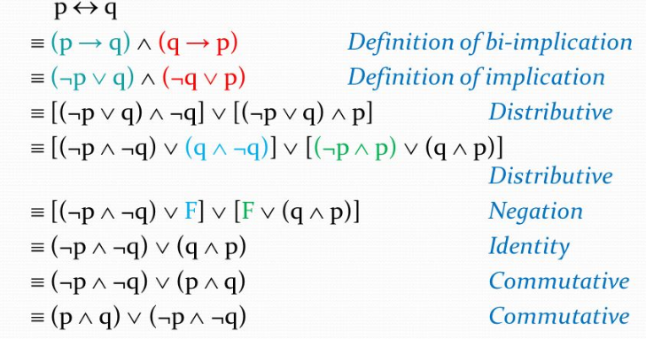

**Question #3: (02 points)**

**Let P (x, y) means “*x + y =* 0”, where x and y are integers. Determine the truth value of the statement. Show proper calculation steps.**

**a) ∃y ∀x P (x, y)**

**Solution: False Let y=1 x + y= -1+1=0 but 0 + 1 ≠ 1 and 1+1 ≠ 2**

**Question #4: (04 points)**

**Suppose the variable x represents Employee and y represents Job, and:**

**P(y): y is a white collar job. Q (x): x is a contractual employee.**

**R(x): x is permanent employee. S(x, y): x is doing y.**

**Write the statement in good English without using variables in your answers.**

**a) ∀x ∃y S (x, y)**

**Solution: All employees are doing a same job.**

**Write the statement using the above predicates and any needed quantifiers:**

**b) Every permanent employee is doing a white collar job.**

**Solution: ∀x ∃y [R(x) ∧ Q (x)]  [ P(y) ∧ S(x,y) ]**

**Question # 5: (04 points)**

**Write the name and rule of inference which is used in each argument below?**

**a) If I go swimming, then I will stay in the sun too long. If I stay in the sun too long, then I will sunburn. Therefore, if I go swimming, then I will sunburn.**

**Solution:**

**Hypothetical Syllogism p  q**

**q  r**

**p  r**

**b) l go swimming or eat an ice cream. I did not go swimming.**

**Therefore, I eat an ice cream.**

**Solution:**

**Disjunctive Syllogism p v q**

**¬ p___**

**q**

**Question #6: (04 points)**

**Use set-builder notation and logical equivalences to establish the De Morgan law.** 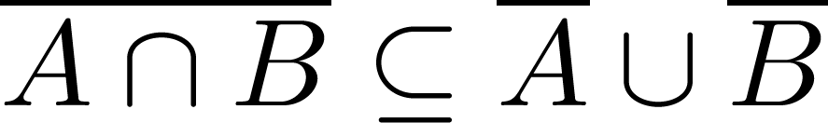

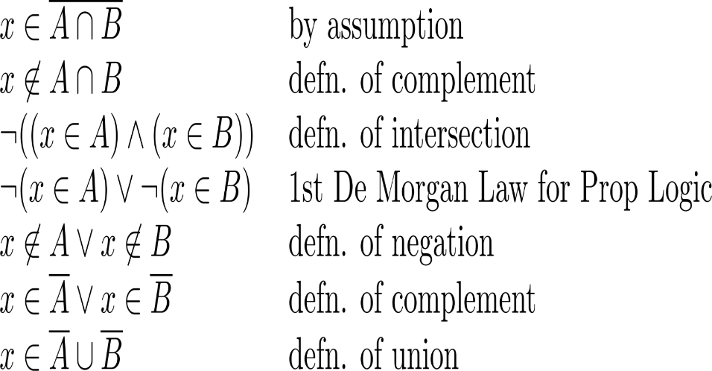

**Question #7: (04 points)**

**In a class of 100 students, 35 like science and 45 like math. 10 like both. How many like either of them and how many like neither? Show proper steps of computation and also draw Venn diagram.**

**Solution:**

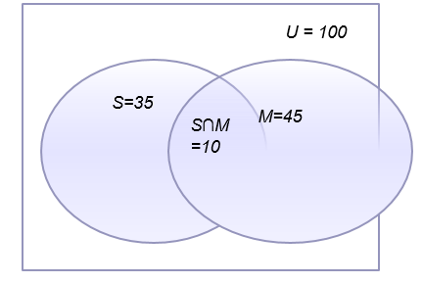**Total number of students, n(µ) = 100**

**Number of science students, n(S) = 35**

**Number of math students, n(M) = 45**

**Number of students who like both, n(M∩S) = 10**

**Number of students who like either of them,**

**n(MᴜS) = n(M) + n(S) – n(M∩S) = 45+35-10 = 70**

**Number of students who like neither = n(µ) – n(MᴜS) = 100 – 70 = 30**

**Question #8: (02 points)**

**Determine whether the function from Z to Z is Injective OR Surjective. Show proper steps.**

**ƒ(n) = $⌈ \frac{n}{2 } ⌉$**

**Solution: It is Surjective (onto function)**

**This can be shown by an example; ƒ (1) = 1, and ƒ (2) = 1.**

**Question #9: (02 points)**

**Let *f* be the function from {w, *x, y, z*} to {1,2,3,4} such that *f(w) =* 2, *f(x)* *=* 3, *f(y) = 4* and *f(z) =* 1. Is f invertible and if so, what is its inverse?**

**Solution:**

**The function *f* is invertible because it is a one-to-one correspondence. The inverse function *f-1*reverses the correspondence given by *f*, so *f-*1(1) *= z*, *f-*1*(*2) *= w, f-*1*(*4) *= y* and *f-*1*(*3) *= x.***

**Question #10: (02 points)**

**Let p, q and r be statements. Determine, using a truth table that statement ((p → q) ∧ (q → r)) → (p →r) is a Tautology.**

**Solution:**

|  |  |  |  |  |  |  |  |
| --- | --- | --- | --- | --- | --- | --- | --- |
| **p** | **q** | **r** | **(p → q)** | **(q → r)** | **(p → q) ∧ (q → r)** | **(p →r)** | **((p → q) ∧ (q → r)) → (p →r)** |
|  |  |  |  |  |  |  |  |
| **T** | **T** | **T** | **T** | **T** | **T** | **T** | **T** |
| **T** | **T** | **F** | **T** | **F** | **F** | **F** | **T** |
| **T** | **F** | **T** | **F** | **T** | **F** | **T** | **T** |
| **T** | **F** | **F** | **F** | **T** | **F** | **F** | **T** |
| **F** | **T** | **T** | **T** | **T** | **T** | **T** | **T** |
| **F** | **T** | **F** | **T** | **F** | **F** | **T** | **T** |
| **F** | **F** | **T** | **T** | **T** | **T** | **T** | **T** |
| **F** | **F** | **F** | **T** | **T** | **T** | **T** | **T** |

***BEST OF LUCK!***